 

CS-114 Fundamentals of Programming (2+1)

DE-41 EE Semester 1

Fall 2019

**LAB REPORT # 06**

|  |  |
| --- | --- |
| **Submitted by** | **Roll No** |
| Ayesha Javaid | 285151 |
| Syndicate A |  |

Instructor In-charge: Dr. Saad Rehman

DEPARTMENT OF COMPUTER & SOFTWARE ENGINEERING

College of Electrical and Mechanical Engineering (CEME)

National University of Sciences and Technology (NUST)

**Lab Number: 6**  
**Lab Title: do while**  
**Aim:**

**To get the better understanding of Do While.**

**Topic(s) covered:**

**Do While.**

**(Tasks starting from next page)**

**Task 1:**

**Code:**

#include <iostream>

using namespace std;

int main()

{

int num;

int total_num;

int max = 0;

int i = 0;

cout <<"Enter amount of total numbers.";

cin >> total_num;

cout << endl;

do

{

cout << "Enter number " << i + 1 << ": ";

cin >> num;

i++;

if (max < num)

{

max = num;

}

}while (I < total_num);

cout << "Maximum number is: "<< max << endl;

system ("pause");

return 0;

}

**Output:**

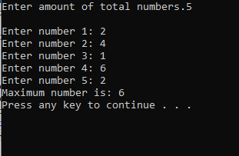

**Task 2:**

**Code:**

#include <iostream>

using namespace std;

int main()

{

int num;

int i = 1;

cout << "Enter number: ";

cin >> num;

do

{

if (num % i == 0)

{

Cout << i <<", ";

}

i++;

}while ( i <= num);

system ("pause");

return 0;

}

**Output:**

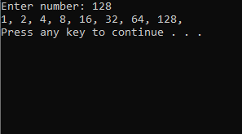

**Task 3:**

**Code:**

#include <iostream>

using namespace std;

int main()

{

int num;

int fictorial = 1;

cout << "Enter number: ";

cin >> num;

int i = num;

while (i> 0)

{

fictorial *= i;

i--;

}

cout << "Fictorial is: "<< fictorial <<endl;

system ("pause");

return 0;

}

**Output:**

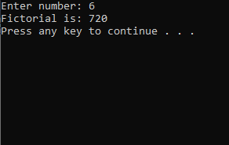

**Task 4:**

**Code:**

#include <iostream>

using namespace std;

int main()

{

int num;

int count = 0;

while (true)

{

cout <<"Enter number: ";

cin >> num;

if (num % 2 != 0)

{

count++;

}

if (count == 5)

{

break;

}

}

cout << "You have entered 5 odd numbers." << endl;

system("pause");

return 0;

}

**Output:**

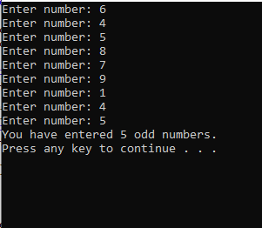

**Task 5:**

**Code:**

#include <iostream>

using namespace std;

int main()

{

int num;

int count = 0;

int i = 1;

cout << "Enter number: ";

cin >> num;

while (I <= num)

{

if (num % i == 0)

{

count++;

}

i++;

}

if (count == 2)

{

cout << "Number is prime number." << endl;

}

else

{

cout << "Number is not a prime number." << endl;

}

system("pause");

return 0;

}

**Output:**

